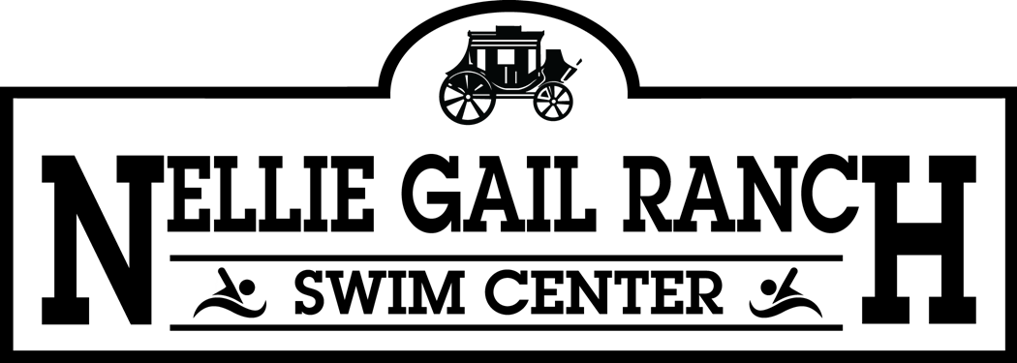

WINTER SWIM PROGRAM SCHEDULE
Swim Center Hours of Operation
Monday - Friday 6:00am - 10:00pm / Saturday & Sunday 6:00am - 7:00pm

Sunday | Monday | Tuesday | Wednesday | Thursday | Friday | Saturday
 | TRILAVIE ADULT  6:00am - 7:00am |  | TRILAVIE ADULT  6:00am - 7:00am |  | TRILAVIE ADULT  6:00am - 7:00am
 | TRILAVIE ADULT  10:00am - 11:00am | TRILAVIE ADULT  10:00am - 11:00am |  | TRILAVIE ADULT  10:00am - 11:00am
 | EVOLUTION SWIM TEAM  3:30pm - 7:00pm | EVOLUTION SWIM TEAM  3:30pm - 7:00pm | EVOLUTION SWIM TEAM  3:30pm - 7:00pm | EVOLUTION SWIM TEAM  3:30pm - 7:00pm | EVOLUTION SWIM TEAM  3:30pm - 7:00pm
SCUBA CLASS  2:00pm - 5:00pm |  |  |  |  |  | SCUBA CLASS  2:00pm - 5:00pm
 |  | TRILAVIE ADULT  7:00pm - 8:00pm |  | TRILAVIE ADULT  7:00pm - 8:00pm
The Nellie Gail Ranch Swim Center has many programs that utilize the pool throughout the year. The pool is open to recreational swimmers during all hours of operation. A swim lane will always be available for members and residents during any swim program. For more info, please contact the Swim Center at 949-831-6660.

